**World Quant University**

**Professor: Ritabrata Bhattacharyya**

**Alpha Design II**

Nikolas Lippmann Pareschi - [nikolaslippmann@gmail.com](mailto:nikolaslippmann@gmail.com)

Introduction: Spyder PEP8 checker is truly a time saver, as I discovered reading the Piazza forum in Python 2. So, I have used it again for all classes and this Project I from Alpha Design II. I tried my best to avoid using modular code.

**Project: Event Trading Using Volatility Ratio**

* + - 1. Identify a specific news source category the effect of which you would like to study – this might be release of economic statistics, employment numbers, quarterly results of a stocks, the budget declarations in India or Fed Rate cuts/rate increases in USA

I used Quandl to download CPI data. In emerging markets like Brazil and Argentina we live the “inertial effect” of inflation. I will try to improve the returns of buying Crude Oil, which usually rises in environments of high inflation. Please use this key if you do not have yours to download the data from Quandl:

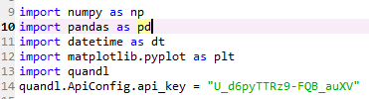

* + - 1. Download and collate data for all historical instances of these news events for the last 5-10 years based on feasibility.

Code:

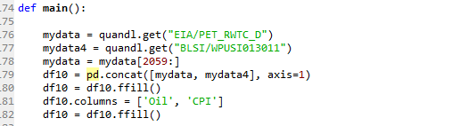

We backtested the data since 1995:

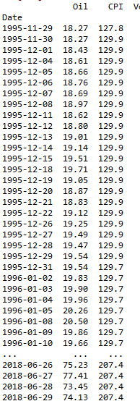

* + - 1. Also download/access data of relevant stocks or broad market indices for the same period

The backtested index is the Crude Oil from QUANDL.

* + - 1. A simple approach to measure the effect of an event is to identify the size of its reaction. This can be done by comparing the volatility of the current day with the average volatility of the recent past, using the true range calculation:

Img1

Programmatically calculate the historical volatility ratios of the preferred market indices and identify the relative effect of the chosen news event in statistical context

The data provided only had close prices, so I used the Spread between a time window higher than a month and calculated the standard deviation of the Spread. We usually have spikes of high inflation so cutting the low volatility periods we will be cutting some scenarios that are not that much inflationary.

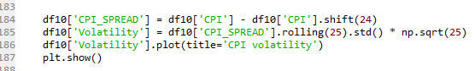

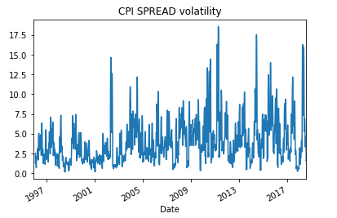

* + - 1. Determine the optimal values of Volatility Ratio that has greatest predictive power in back-tests

I tried several values and the bests were around 1.

* + - 1. Device a simple trading strategy that trades any of the broad market indices based on buy-sell signals generated from Volatility as an event driven indicator

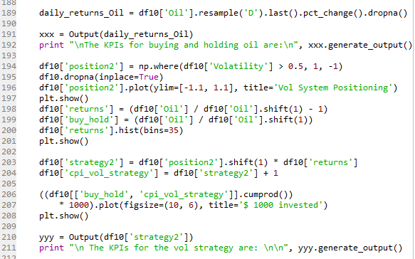

* + - 1. Consider Equal amount invested for every trade

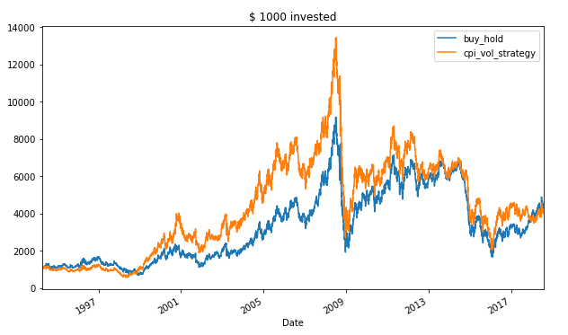

* + - 1. Clearly mention and explain all entry/exit/position sizing rules

We invest when our volatility measure is above 1 and we short sell when it is below / equal to 1.

* + - 1. Estimate historic performance for such a system and calculate all the relevant KPIs as marked below

Win %

Win to Loss Ratio

Mean Return Per Trade

Maximum Consecutive Losers

Maximum Drawdown

CAGR

Lake Ratio

Gain to Pain Ratio

I used the class provided by Professor Steven Stelk in his discipline (Risk Management) on the piazza forum.

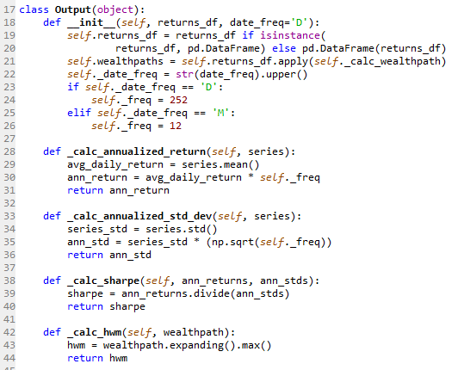

Results:

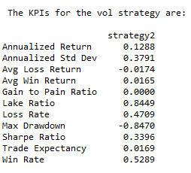

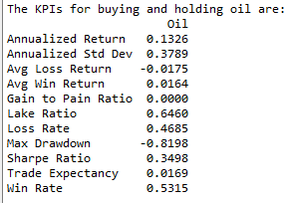

Honestly, I do not see any clear pattern. The results were a little better than the Buy and Hold but that could be to luck. It is likely that oil prices predict more the CPI than CPI predicts oil prices, despite the inertia effect.